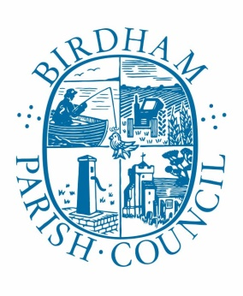

Notice of Conclusion of audit
Annual Return for the year ended March 31st 2020

Sections 20(2) and 25 of the Local Audit and Accountability Act 2014
Accounts and Audit Regulations 2015 (SI 2015/234

- The audit of accounts for Birdham Parish Council for the year ended 31st March 2020 has been completed and the accounts have been published.

- The Annual Return is available for inspection by any local government elector of the area of Birdham Parish Council on application to:

The Clerk and RFO
Imogen Whitaker
01243 575094
mailto:clerk@birdhamparishcouncil.gov.uk

- Announcement made by: Imogen Whitaker
Clerk and RFO

- Date of announcement: 26th November 2020

