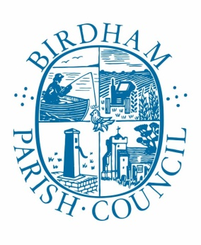

Notice of Public Rights and publication of unaudited Annual Return
Accounts for the year ended 31st March 2020

Sections 20(2) and 25 of the Local Audit and Accountability Act 2014
Accounts and Audit Regulations 2015 (SI 2015/234

NOTICE

- Date of announcement: 20th May 2020

- Each year the smaller authority's Annual Return needs to be reviewed by an external auditor appointed by the Smaller Authorities Audits Appointments (SAAA). The unaudited annual return has been published with this notice. As it has yet to be reviewed by the appointed auditor, it is subject to change as a result of that review.
Any person interested has the right to inspect and make copies of the accounting records for the financial year to which the audit relates and all books, deeds, contracts, bills, vouchers, receipts and other documents relating to those records must be made available for inspection by any person interested. For the year ended 31st March 2020 these documents will be available on reasonable notice by application to:

The Parish Clerk (details below).

Commencing on: Monday 8th June 2020

And ending on: Friday 17th July 2020

- Local government electors and their representatives also have:
- The opportunity to question the appointed auditor about the accounting records; and
- The right to make an objection which concerns a matter in respect of which the appointed auditor could either make a public interest report or apply to the court for a declaration that an item of account is unlawful. Written notice of an objection must first be given to the auditor and a copy sent to Boxgrove Parish Council

The appointed auditor can be contacted at the address in Paragraph 4 below for this purpose between the above dates only.

- Birdham Parish Council's Annual Return is subject to a review by the appointed auditor under the provisions of the Local Audit and Accountability Act 2014, the Accounts and Audit Regulations 2015 and the NAO's Code of Practice 2015. The appointed auditor is:

Moore, (Ref RD/HD), Rutland House, Minerva Business Park, Lynch Wood, Peterborough PE6 2PZ

- This announcement is made by I. Whitaker, Clerk and RFO to Birdham Parish Council

