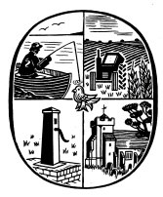
Birdham Parish Council
28 Langdale Avenue, Chichester, West Sussex, PO19 8JQ
Tel : 01243 790402
Email : clerk@birdhamparishcouncil.org.uk Website : www.birdham.org.uk
Chairman of the Council : Cllr Laurie Pocock
Clerk to the Council : David J Siggs

ANNUAL PARISH MEETING
The Annual Parish Meeting will be held on Saturday the 13th May 2017 at 11:00am in Birdham Village Hall. All residents of the Parish are welcome and encouraged to attend.

AGENDA
- Welcome and introduction by Chairman – Cllr Laurie Pocock
- Approve the minutes of the last Annual Parish Meeting.
- Chairman’s Annual Report.
- Matters arising from the Chairman’s Report
- Surface Water Flooding and Ponds update
- Report on A27 Workshop.
- Any other business.
- Close

Signature LPocock Date 2nd May 2017.
Cllr L Pocock
Chairman of the Parish Council

Tea and Coffee will be available from 1030am

